

INSTRUCTIONS

- Deal Go Fish cards to players. Have players place the cards face up in front of them.
- Place the crocodile cards face down in front of you.
- Turn one crocodile card over and call out the word.
- Players look at their cards, if they have a match they say “SNAP” .
- The first to call “SNAP” gets to discard the card
- Continue to play until a player has gotten rid of all of his/her fish cards.

clear

good-bye
Snap

High Frequency
Words

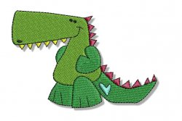



Book 5
Book 5
Book 5

nothing

ready

Book 5

Book 5

kinds

toes

color

Book 5

Book 5

Book 5

front

sorry

any

Book 5

Book 5

Book 5

hair

only

climbed

Book 5

Book 5

Book 5

toward

building

welcoming

Book 5

Book 5

Book 5

fooling

thought

earth

Book 5

Book 5

Book 5

tomorrow

boy

took

Book 5

Book 5

Book 5

table

answered

done

Book 5

Book 5

Book 5

great

almost

traveled

Book 5

Book 5

Book 5

pools

together

baby

Book 5

Book 5

Book 5

able

poured

blue

Book 5

Book 5

Book 5

heard

pushed

Book 5

Book 5

Book 5

